Bandit level 3 to level 4
For login into level 3 use the username as
Then asusual use ls command.
But with ls command add -la to display all the files including its hidden files so the command becomes ls -la.
Then you will get a inhere as the folder name.
Then you can use the cd inhere command.
Cd stands for change directory and the use of cd inhere is to moves into the inhere folder.
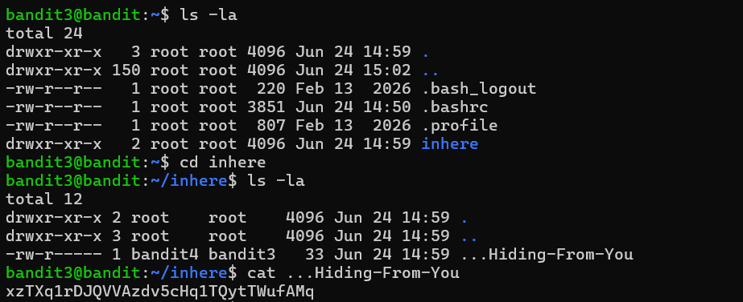
Then continue with ls-la command and then continue by cat command.
Finally you will get the password the next level.

